**Subject: Mobile Application Design**

**Assignment 1**

**Group Members**

**Chanchal Pauly Thattil**

**Negin Adibi**

**Kavitha Vijayan**

**Sonalben Chauhan**

**App idea: Indian Restaurant Mobile application**

Restaurant mobile apps help to deliver the trending customer experience with advanced functionalities to reserve a table in advance or order food at home. The fully functional mobile app helps you to interact and connect with your customers. Order food online, reserve seats and book for events.

1. **Intended users of application:**

The people who want to order food from the Restaurant and book reservations and find the offers and menu details.

As it is an Indian restaurant, we assume that our most customers will be Indians who live in Waterloo, Kitchener area.

Since there are so many Indian students who study in waterloo the region, the expected audiences will be Indian students between the age 19 to 35. From this student’s group, male students may be the ones who would be the main customers compared to female students as male students are less interested in cooking.

We are planning to make a food menu in a way that can afford by people with low income also. As most of the customers will be students, they will have a limited income only.

The customers will use this app mostly to order food online, and check offers and promotions (There will be some offers only for mobile app users.). Also making reservations for parties and events. We are planning to have discounts for people who download the app for the first time. There will be cashback offered so people will tend to use it again.

The app users can book the student zone using the app and they can have food and study and borrow laptops using free Wi-Fi.

The app users can get referral bonus points who refer the app to others using their referral code.

For feedback, complaints, and suggestions, there will be options available in the application.

There will be different cuisines available from different parts of India and it will attract more people to use the mobile application.

People in every economic background will be using this app as in very price there will be items available.

People with every educational background will be using this app as most of the people are familiar with the mobile applications and know how to use it

1. **Business case for development of app**

This app comes under the category of Travel and Hospitality.

Benefits of restaurant app development:

* To search for restaurants, menus, locations and hours of operation 83 % of adults use their mobile phones or tablets.
* 3 out of 4 customers prefers to use restaurant when there is no crowd.
* 79% agree that restaurant technologies attract them more into the place.
* 36% agree that the feature to book a table online is a necessary feature.
* Four in five restaurant owners says that mobile application helped them with increase sales, and attracted more customers.

Features

* Online ordering and pre- ordering
* Payment processing
* Customized menu
* Online table reservation
* Location and map
* Push notifications (offers, deals, news and promotions)
* Loyalty programs
* Ratings and Reviews
* Buffets
* Student corner
* Kids menu
* Referral bonus
* Cashbacks
* Filters and sorting
* Calendar events
* Order tracking
* Points, Coupons and events
* In app calling

**Cost for developing the app:**

Project, database setup – 32 hours

Home page – 20 hours

Gallery – 9 hours

Menu – 78 hours

Order delivery – 56 hours

Map – 13 hours

Book a seat – 34 hours

Cart – 25 hours

Checkout – 36 hours

Orders – 35 hours

Payment gateway – 21 hours

Notifications – 14 hours

Profile – 28 hours

Settings – 12 hours

Coupons – 12 hours

Events – 9 hours

So, total hours will be 434 hours and if we imagine 35 CAD per hour, total cost will be 15,190 CAD.

**Revenue streams**

* **Delivery charges**

It can be a percentage of total amount or a flat fee. Delivery charges are a way for stable income. But avoiding delivery charges for more than some amount purchase can attract more customers.

* **In app purchases**

Uses app as another sales channel. It is important that the app should remain functional without any digital upgrades. It can refer to ad removal, virtual currency

* **Freemium app model**

Offers free basic and premium versions of your app. It is to create a customer base and attract more to pay for exclusive features

* **Social media outreach**

Selling cookies to other websites who needs to know the customer preferences

* **More customers and sales**

Having a mobile app and services can attract more online orders and more customers.

1. 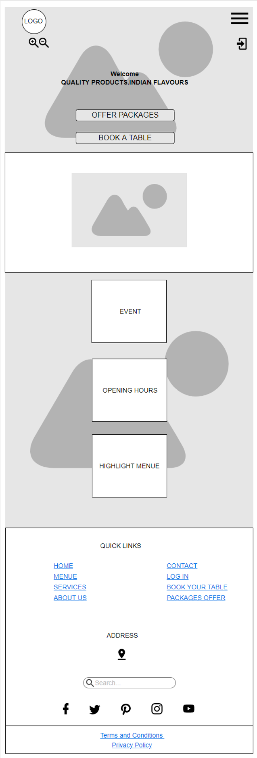**Moqup**

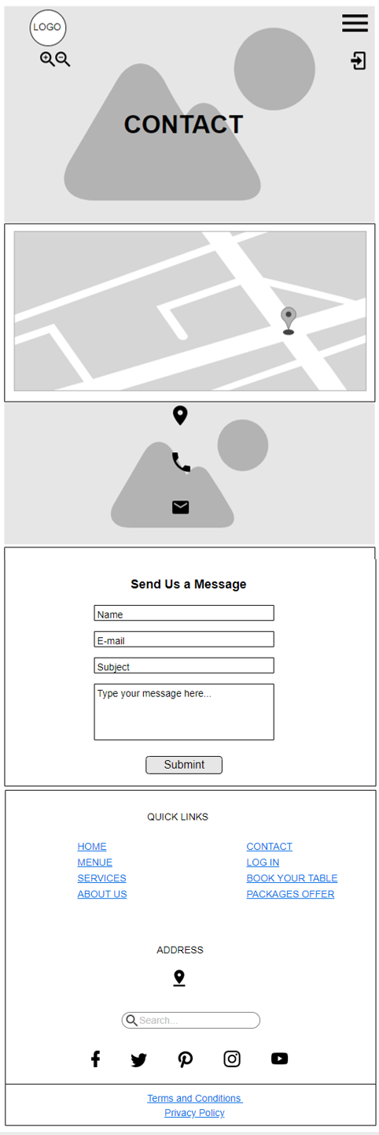

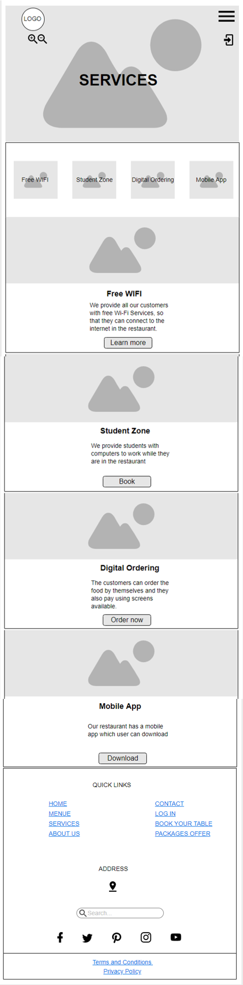

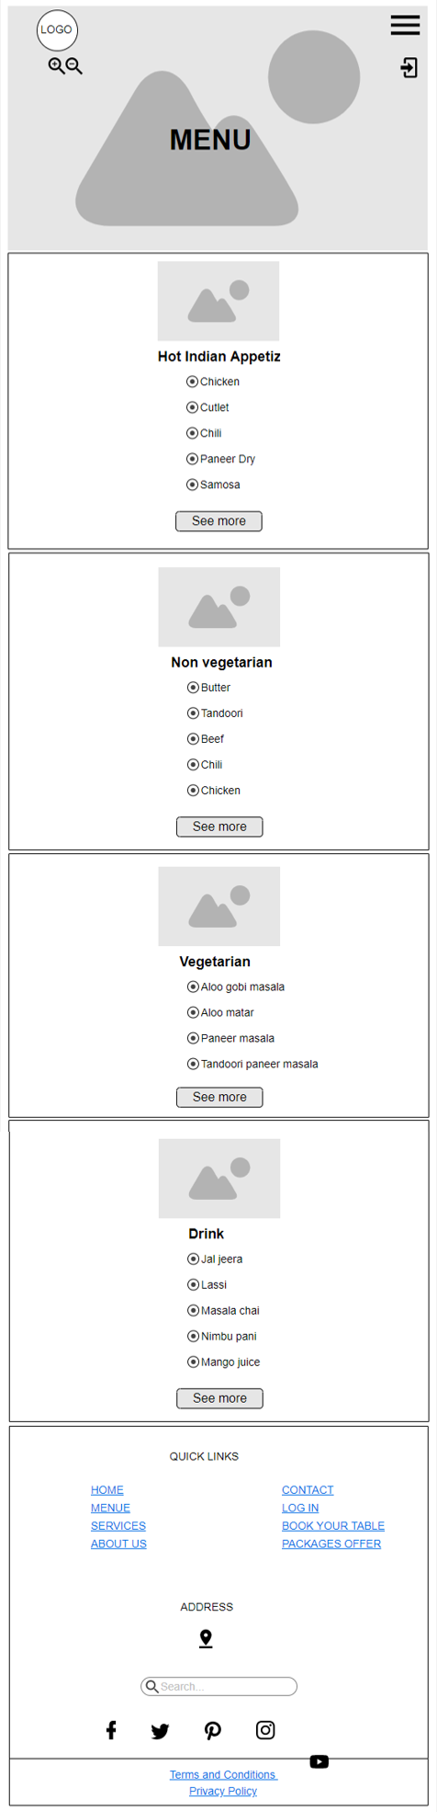 

**Subject: Mobile Application Design**

**Assignment 2**

**Group Members**

**Chanchal Pauly Thattil**

**Negin Adibi**

**Kavitha Vijayan**

**Sonalben Chauhan**

**App idea: Indian Restaurant Mobile application**

**1. Enumerate the major features of this application.**

1. **Offers:** One of the main features of our restaurant mobile application is offers. So, when users installed the application can easily get notification when there are some special offers.
2. **Student zone:** It is a corner in the restaurant where students can come and access computers. By that they can come here and do their college work in the restaurant. This feature enabled the users to reserve the zone easily.
3. **Online ordering:** This can be the most important feature of this mobile application. We decided to take advantage of technology for making the ordering process more convenient. Our clients can order by mobile app instead of standing in line and wasting their precious time.
4. **Online table reservation:** Since these days people are more preferring to spend some quality time with their friends and family outside of the home so restaurants are so busty. We decided to have this feature to boost the functionality of the app and at the same time reduce the waiting time in busy days.
5. **Contact feature:** We consider this one as a main feature since we still have those people who are not that much into technology so by installing this app and using the contact section these people can easily contact us. We provide them with telephone number and address.
6. **Chat:** The chat feature will aid users to have online chat with the call center and they will get answer for their queries

**2. Identify the event triggers that influence the work flow of the user experience.**

* Users can collect point when they order online and can spend that point for ordering food
* Users can see the menu by clicking the menu option in this app so they will be able to check the menu in advance
* By pressing online table reservation users will be able to arrange a meeting for example
* Subscribing will able users to be aware of the events
* Some students prefer to do their school work and at the same time have their food and save time so they can book student zone which leads to have lunch/dinner in an atmosphere like library
* Users have a more convenient way to order their food without wasting time and getting bored.
* By ordering food through mobile app users can collect point which leads them to some more special offers like ordering free food just by spending their points
* Users can see the menu in the application so they will get some idea about the food in advance
* Users can easily arrange meeting in the restaurant since it has an online table reservation
* There are some events come up weekly so the user can decide to go restaurant on a certain day which is event and foods are cheaper
* It is a good opportunity for the student to take advantage of this opportunity to book a student zone and have their food at the same time they are doing their school work. When users are in rush they can easily order online by application and save time

**3. A use case diagram.**

Use cases

1. View Menu

User can see all the menu options

1. Search

User can input the keyword and search quickly

1. Social media links

User can follow on social media to get latest updates

1. Chat

User can have a live chat

1. Services

User can see the services like WiFi, mobile app, student zone and digital ordering.

1. Contact

User can see the phone number, address, email and the map to the location

1. Book table

User can enter the details with date and time and reserve the table

1. Zoom in / zoom out

User can zoon in and out

1. Book Student zone

User can enter the details and book the student zone area

1. Order online

User can select the food and input the address details and make an online order.

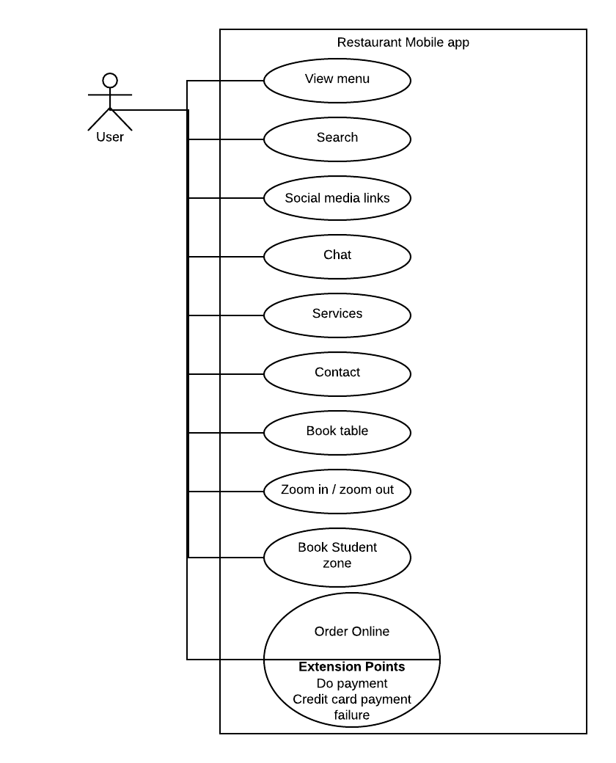

**4. A list of functional requirements (what features must the application do).**

1. First, we have to make sure that we have internet connection
2. Then our restaurant's application is own both iOS and Android app version
3. Setup, updates and support are freely provided for users
4. For online ordering feature users should have account to be able to check the restaurant menu, place an order and all those abilities to manage their orders. In addition, all these steps should be as simple as possible for customers
5. For online table reservation users should have access to available time and date
6. App should also provide users with the option for pickup or delivery order
7. Users should have access to the contact so that they can call the restaurant
8. In the contact section, app should show the map of the restaurant location and users should be able to zoom in and zoom out the map
9. Creating account for collecting point and order placement. So that users can track their order, review their profile and order history and managing their profile

**5. A list of non-functional requirements (what performance metrics must the application adhere to).**

1. Application reliability

Connection will stable since we uploaded in google server

1. Efficiency

It won’t use much data and so loading will be faster

1. Security

Validating inputs of the form, SQL injection, and taking steps for cross-site scripting

1. Maintainability

Independent of hardware, software or component

1. Consistency

App has similar design in all pages and buttons and menu options are consistent

1. Modifiability

App is easily modifiable

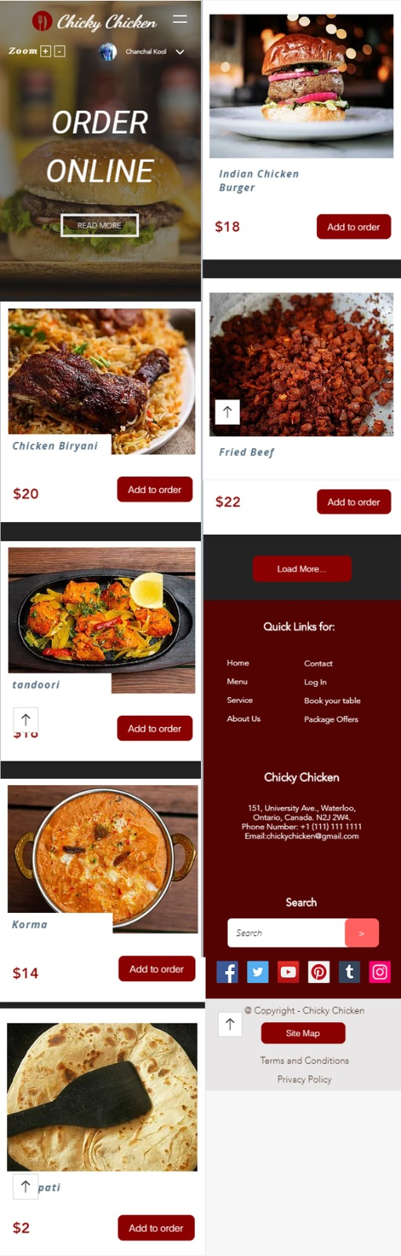

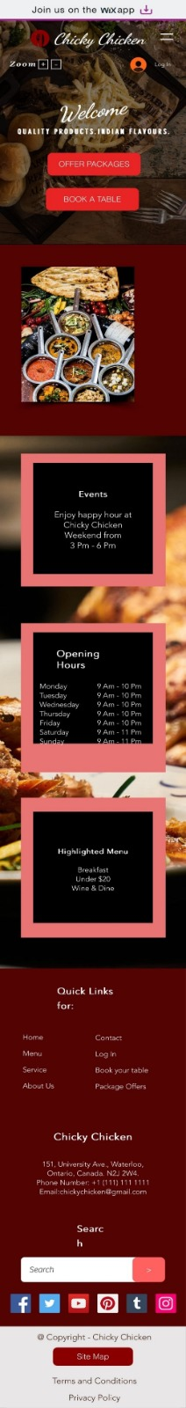 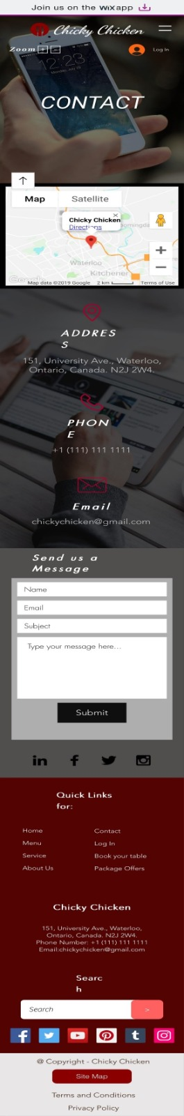 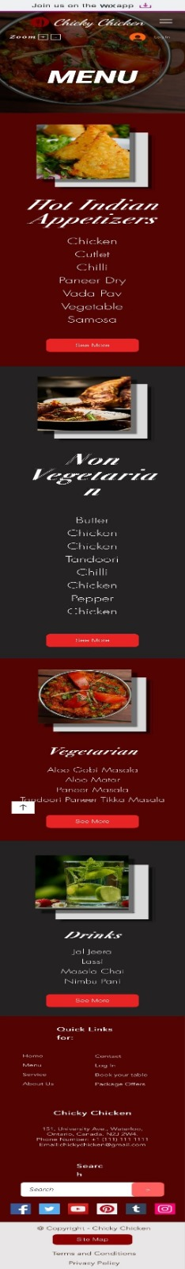

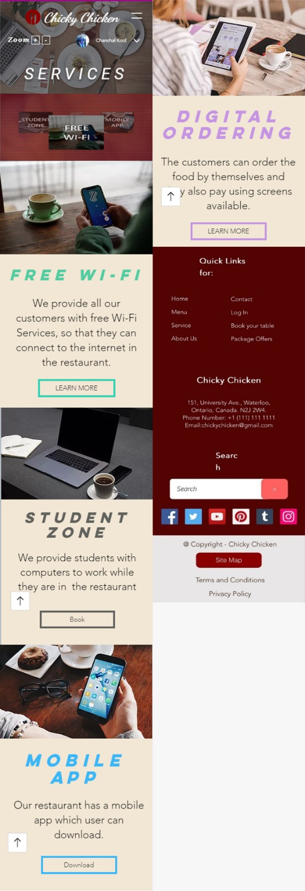 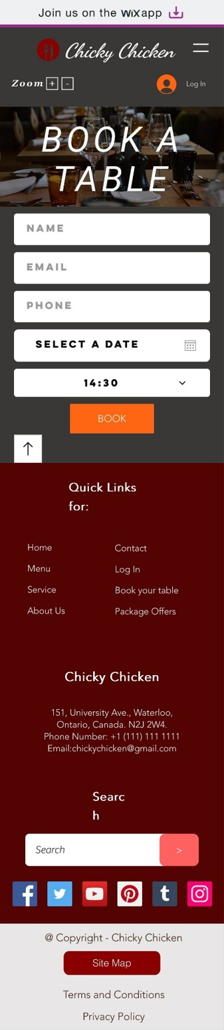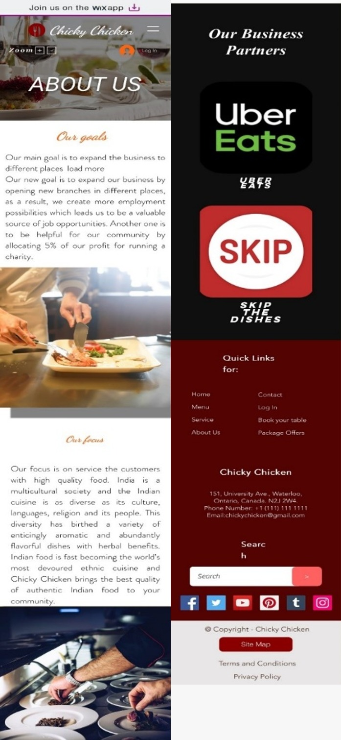

**References**

[https://www.lucidchart.com](https://www.lucidchart.com/pages/?noHomepageRedirect=true)